**Assignment – 19**

**VIEWS**

Q1. Create a view that shows all of the customers who have the highest ratings.

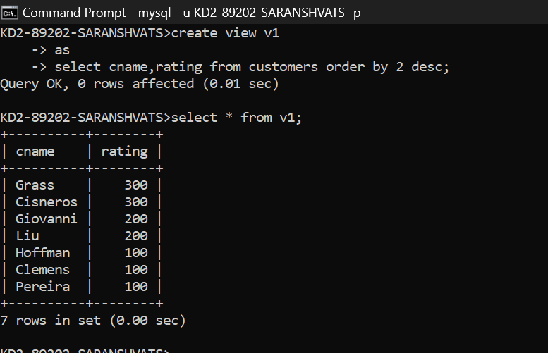

**2) Create a view that shows the number of salespeople in each city.**

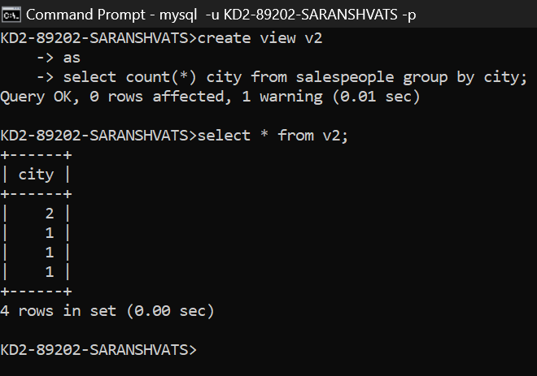

**3) Create a view that shows the average and total orders for each salesperson after his or her name. Assume all names are unique.**

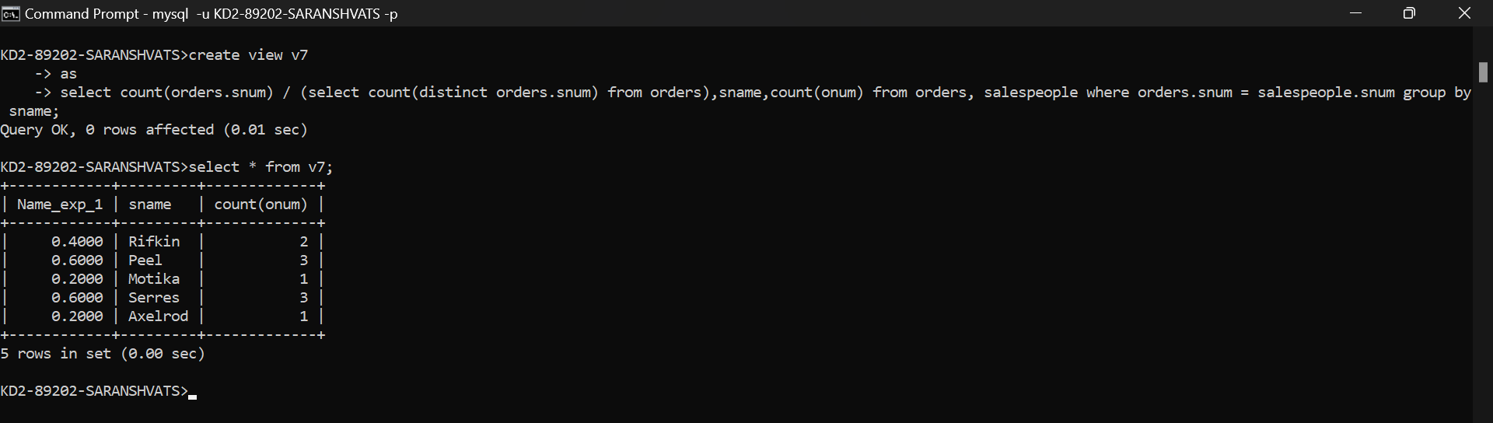

**4) Create a view that shows each salesperson with multiple customers.**

